**The LNM Institute of Information Technology**

**Dept. of ECE, Subject: Cognitive Radio**

**Mid-semester Make-up Examination, Date: 07-06-2020, Full Marks: 30 (5x6)**

Q1. A) Consider Fig. 1, depicting the primary receiver ($∆$) being affected by *N* secondary interferences from a disk of radius *l*. The total interference power at the primary receiver is:

$$γ_{l}= \sum_{j=1}^{N}{g\left(r_{j}\right)P_{j}h_{j}}$$

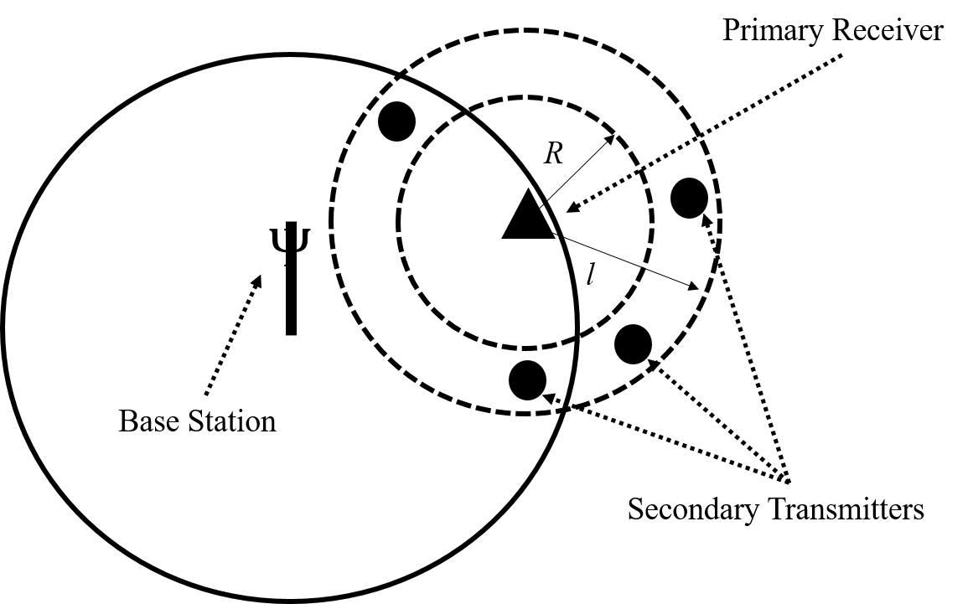

Fig. 1

Identify the parameters: $r_{j}$, $g\left(r_{j}\right)$, $P_{j}$ and $h_{j}$

B) What is the expression for the interference temperature at the primary receiver i) for the above case; and ii) when the primary receiver has AWGN power N0,  along with the interference γl..

Q2.A) Consider a 3-node relayed system as shown in Fig. 2

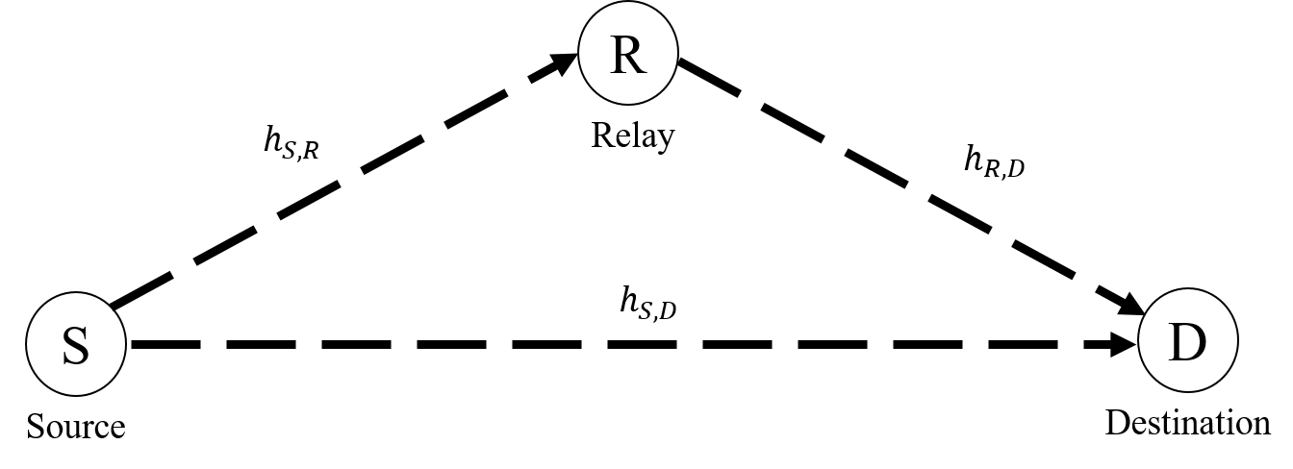

Fig. 2

Assume both source and relay transmit at the same power *P.* Write the expression of the output signal at destination (D) in the following 2 phases :

Phase 1 (source sends signal to destination and the relay), $y_{S,D}= ?$ [for S🡪D communication]

Phase 2 (relay sends signal to destination) $, y_{R,D}= ?$ [R🡪D communication using AF protocol]

B) Find the capacity of the above system, given destination ${\left.SNR\right|}_{phase 1}={\left.SNR\right|}_{phase 2}=10 dB$

Q3. A) The complex envelop of a Rician fading channel is given by

$$E= E_{0}+\sum_{n=1}^{N}{E_{n}e^{jθ_{n}}}$$

Define Rician factor *KdB*  in terms of the above parameters $E_{0}$ and $E_{n}$.

B) Draw the low-pass (baseband) equivalent model of a Rayleigh channel.

Q4 A) Write the complex envelope of the following radio frequency signal

$$x\left(t\right)= A_{cm}\cos\left(ω_{c}t+ θ\right)-A_{sm}\sin\left(ω_{c}t+ θ\right)$$

B) A received signal at a wireless receiver is given by y = h s + n, where s = √P, n is a zero-mean Gaussian variate with variance σn2 and h is Rayleigh distributed. Find the receiver SNR if the second moment of h is 8

Q5. A) Define $P_{FA}$. $P_{MD}$ and $P_{D}$ considering spectrum sensing as a binary hypothesis problem. Indicate these parameters on the Receiver Operating Characteristic (ROC) curve.

B) Write down the conditions for a wireless channel to be both frequency flat and time flat.